Aztertu ondoko Ethermet trama eta ezaugarri garrantzitsuenak azpimarratu:

0000 22 1a 95 d6 7a 23 86 93 23 d3 37 8e 86 dd 60 0d "...z#..#.7...`.

0010 68 4a 00 7d 06 40 fc 00 00 02 00 00 00 02 00 00 hJ.}.@..........

0020 00 00 00 00 00 01 fc 00 00 02 00 00 00 01 00 00 ................

0030 00 00 00 00 00 01 a9 a0 1f 90 02 1b 63 8d ba 31 ............c..1

0040 1e 8e 80 18 00 cf c9 2e 00 00 01 01 08 0a 80 1d ................

0050 a5 22 80 1d a5 22 47 45 54 20 2f 68 65 6c 6c 6f ."..."GET /hello

0060 2e 74 78 74 20 48 54 54 50 2f 31 2e 31 0d 0a 55 .txt HTTP/1.1..U

0070 73 65 72 2d 41 67 65 6e 74 3a 20 63 75 72 6c 2f ser-Agent: curl/

0080 37 2e 33 38 2e 30 0d 0a 48 6f 73 74 3a 20 5b 66 7.38.0..Host: [f

0090 63 30 30 3a 32 3a 30 3a 31 3a 3a 31 5d 3a 38 30 c00:2:0:1::1]:80

00a0 38 30 0d 0a 41 63 63 65 70 74 3a 20 2a 2f 2a 0d 80..Accept: */*.

00b0 0a 0d 0a ...

Aztertzerakoan, tramen barneko protokoloak estekan agertzen direnak direla kontutan izan:

Ethernet:

<https://en.wikipedia.org/wiki/EtherType>

Ohiko balioak (Ethertype):

**IPv4** = 0x0800; **ARP** = 0x0806; **RARP** = 0x8035; **IPX** = 0x8137; **IPv6** = 0x86dd;

**EtherCAT** =0x88a4; **AppleTalk** = 0x809b...

IP (v6 eta v4):

<https://en.wikipedia.org/wiki/List_of_IP_protocol_numbers>

Ohiko balioak:

**TCP** = 0x06, 6; **UDP** = 0x11, 17; **ICMP** = 0x01, 1; **IPv6-ICMP** = 0x3A, 58...

* **IPv6 tramen formatua:**

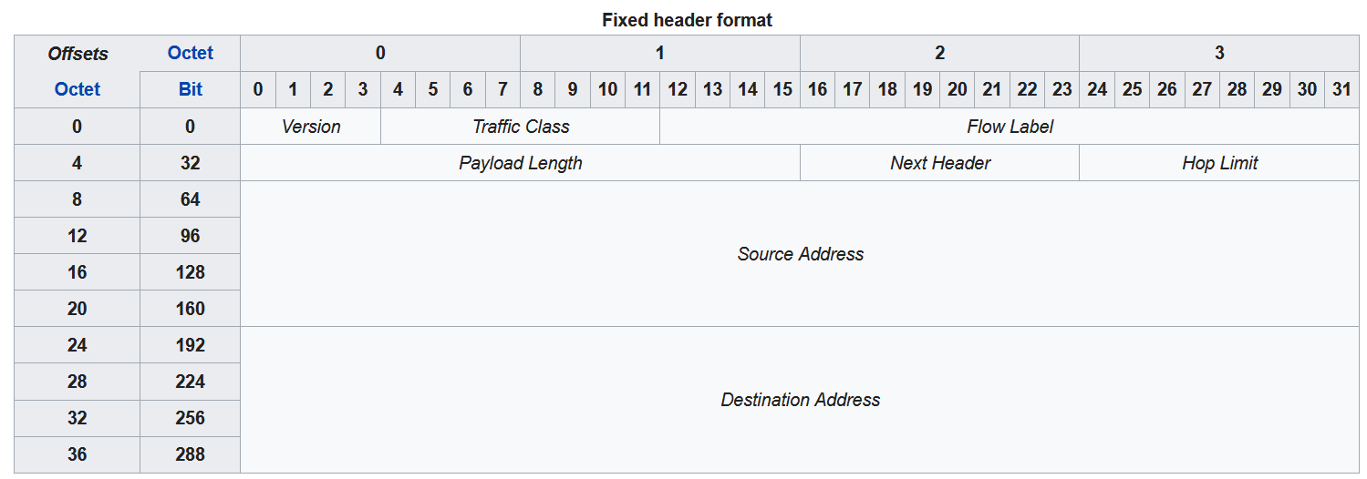

* **Ethernet tramaren formatua**



* **IPv4 goiburuaren formatua**

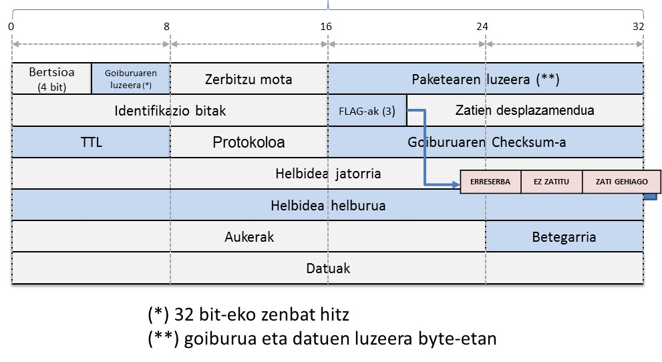

* **TCP goiburuaren formatua**

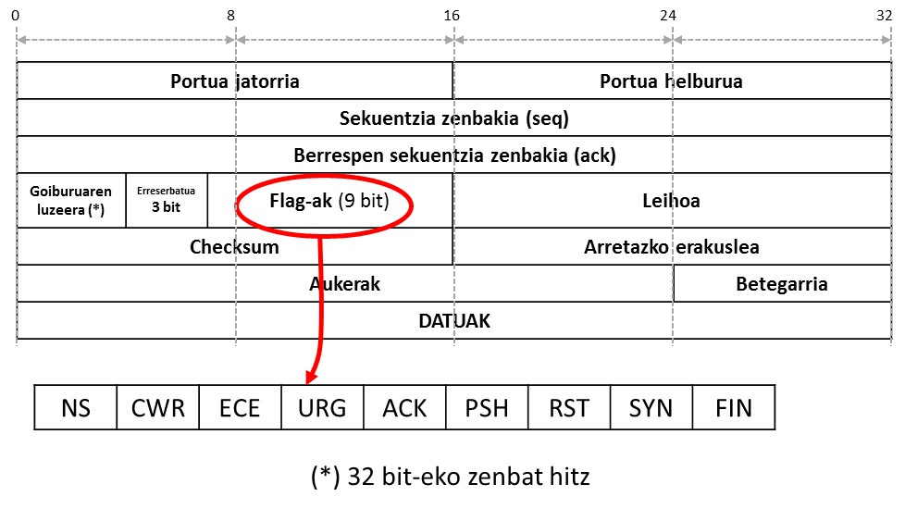

* **UDP goiburuaren formatua**



**Checksum**

**Helmuga portua**

**DATUAK**

**UDPren Luzera**

**Jatorrizko portua**